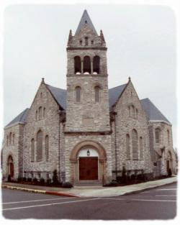
Cynthiana Christian Church Scholarship Fund Application
Applicants for these scholarships must be a member of the Cynthiana Christian Church (Disciples of Christ).
Each applicant must attach a transcript showing a GPA of 2.5 or higher for the semester just completed. Scholarships are awarded only to undergraduates and for a maximum equivalent of 10 semesters. Please note deadlines for filing applications as noted in church correspondences (i.e. bulletin, newsletters, website, etc.). Late or incomplete applications will not be considered.
The General Scholarship Fund was established in 1961 by a small group of members who wanted young people to further their education beyond high school. The fund is maintained through memorial donations. Reasonable guidelines denote respect for the fund and the contributors to it.
The Arnold/Slade Scholarship was Initially established as a trust from A.T. Arnold and his wife, Mary Cassidy Arnold, along with a separate trust from C.B. Slade. The interest from these combined trusts make-up this scholarship.
The Toadvine Scholarship was established in 2020 in memory of Billy Bob Toadvine. He was a 1960 graduate of the University of Kentucky School of Agriculture, where he learned the value of an education. After a successful career in agriculture, he wanted to assist others whose desire is to pursue a higher education.
Please identify the scholarships in which you are interested in applying:
General Scholarship Fund | Arnold/Slade Scholarship | Toadvine Scholarship

Name
Address
E-mail
Phone #
Parents’ names
List names and grades of siblings

High School from which you graduated
Year in which you graduated high school
College/Trade School Attending
GPA from semester just completed (attach transcript)

Cynthiana Christian Church Scholarship Fund Application
Applicants for these scholarships must be a member of the Cynthiana Christian Church (Disciples of Christ).

What career do you plan to pursue?
If you are receiving other scholarships, please list them and their respective amounts.
Are you planning to work to help pay your way to college? If so, what job do you have in view now?
Your annual income

What has been your participation in the Cynthiana Christian Church (Disciples of Christ) activities?

What role does your faith play in the choices you make as a student?

________________________________________ ______________
Applicant Signature Date

